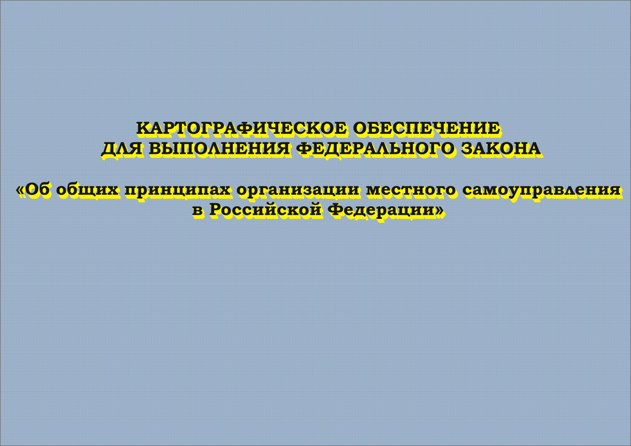
Cartographic application for compliance with the federal law
“On general principles of organization of local self-government
in the Russian Federation
CARTOGRAPHIC APPLICATION FOR COMPLIANCE WITH THE FEDERAL LAW “ON GENERAL PRINCIPLES OF ORGANIZATION OF LOCAL SELF-GOVERNMENT IN THE RUSSIAN FEDERATION”
D.N. Timerkaeva

To effectively and efficiently develop territories and to provide successful activities of executive bodies it is necessary to have accurate and trustworthy information about the territory and its boundaries.

The Federal law of October 06, 2003 № 131 “On general principles of organization of local self-government in the Russian Federation” sets forth the general legal, local, organizational and economic principles for organization of local self-government, assurance of its realization and delimitation of authorities of bodies of state power of constituent entities of the Russian Federation in the sphere of self-government.

Following the enactment the Administration of the Chelyabinsk region acts as an owner of project on elaboration of the maps of municipal units of the Chelyabinsk region and the description of boundaries of municipal units.
- 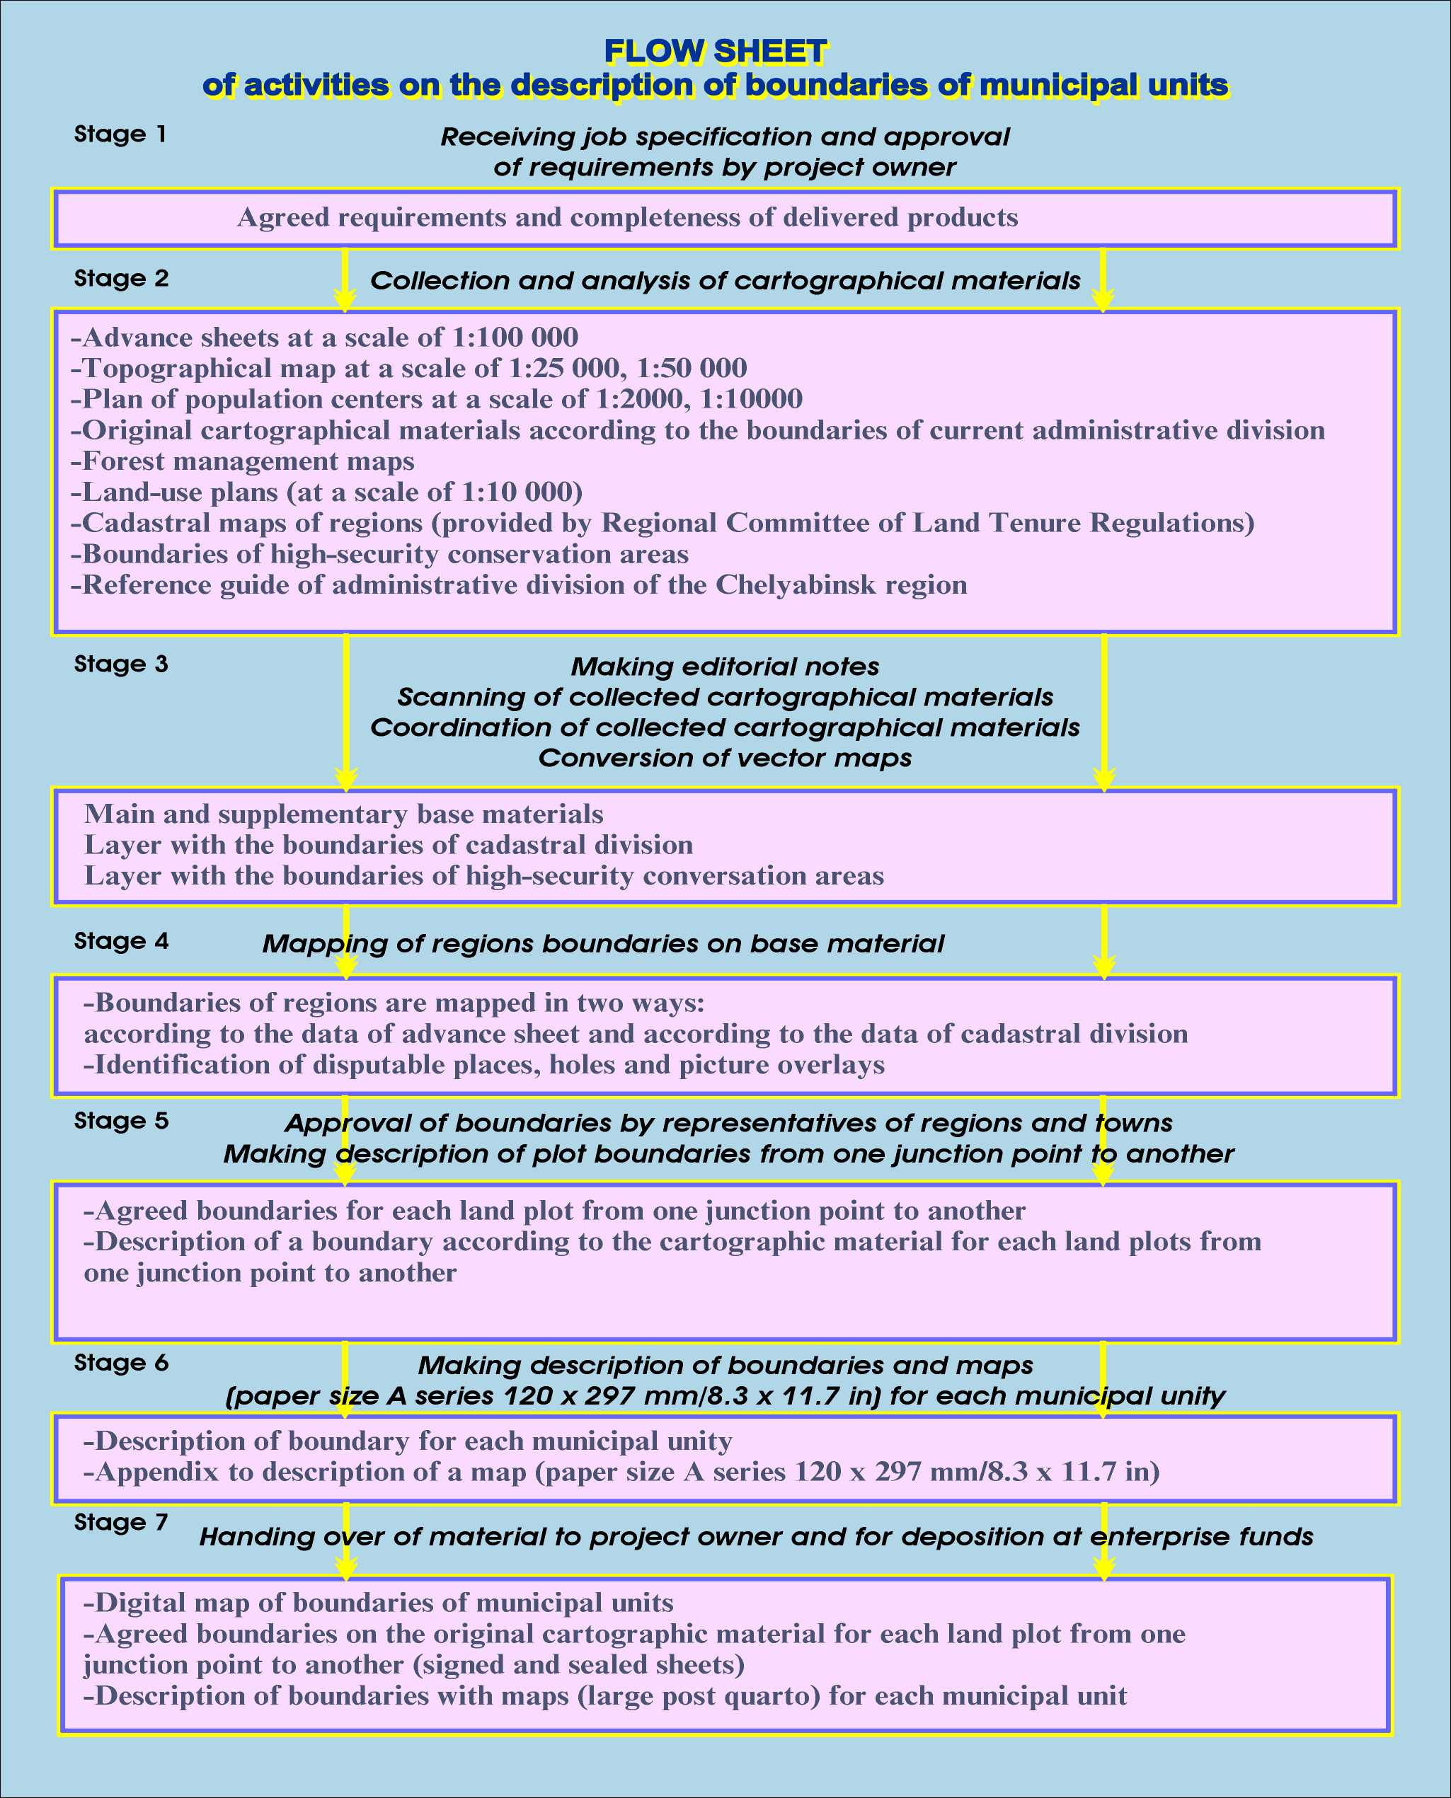

Correct mapping of the boundaries of municipal units required the record of all performed works, so original materials were selected in four main directions:
1. Cartographic material:
  - topographic maps at a scale of 1: 25000 and 1:50000, advance sheets at a scale of 1:100000;
  - land-use plans at a scale of 1:10000 and 1:25000;
  - forest management maps at a scale of 1:25000;
  - large scale plans for build-up areas.
2. Materials of previously completed works – reports on description and coordination of boundaries of the Chelyabinsk region, the Sverdlovsk region, the Kurgan region, and the Republic of Bashkortostan;
3. Materials of cadastral division and the boundaries of high-security conservation areas.
4. Materials of population centers, railroads and motor roads of the Chelyabinsk region.
As a result, the common control had to be set with departmental information.
Maps of different scales were considered as the common control; finally, the topographic map at a scale of 1:25 000 was accepted as the common control.
Cadastral division was carried out in national, local and false grid system. Conversion of junction points from local and false grid systems into national system resulted in unregistered or twice registered land plots.
Forest management and land-use maps were created not by continuous mapping of all the territory, but by mapping of a certain municipal unit and in different grid systems. As all cartographic materials were converted into one grid system, it resulted in problems with bringing together all the material. Part of the territory remained not covered by cartographic material, and some parts were mapped twice. It was difficult to decide what should be accepted as the base material. Territories of the large population centers did not have any cartographic base at all. That is why topographic maps were chosen.
Topographic maps of various scales were considered. First maps at a scale of 1:100 000 was accepted, as they are advanced sheets with mapped boundaries of current administrative division, but they are not comprehensive enough to coordinate boundaries.

It is common knowledge that the bigger the scale the more accurate and detailed the map is (e.g., scale ratio 1:10 000 provides a very detailed map, but not all the region is covered by it). Rescaling results in the problems with generalization of an object.
Finally, topographic maps at a scale of 1: 25 000 were singled out, as all the territory of the region is covered by these maps, and they are rather comprehensive.
Description procedure was approved by the Legislative Assembly of the Chelyabinsk region. Two description procedures were considered.
One procedure is a clockwise description of a boundary. First the northern side of the boundary is described, then – eastern, southern and western sides. This procedure has a number of advantages, as a boundary is described in one direction, and it is easy to find it on the map by a point number. But there are some drawbacks as well. First, it is not evident from the description, between what municipal units this boundary lies which may be crucial. Further, the description of the adjoining region would be different, as it would be made counterclockwise, which significantly complicates approval procedure and description of the boundary.
The second procedure is a description of land plots between municipal units from one junction point to another. Te advantage of this method is that the description of adjoining regions is made in the similar manner. So if during approval procedure any amendments are made, the numbering is changed not for the entire description of a boundary, but only for this section. The weak point is that the description is made counterclockwise, so in order to find a point on the map one should also know its number and the regions between which this boundary lies.
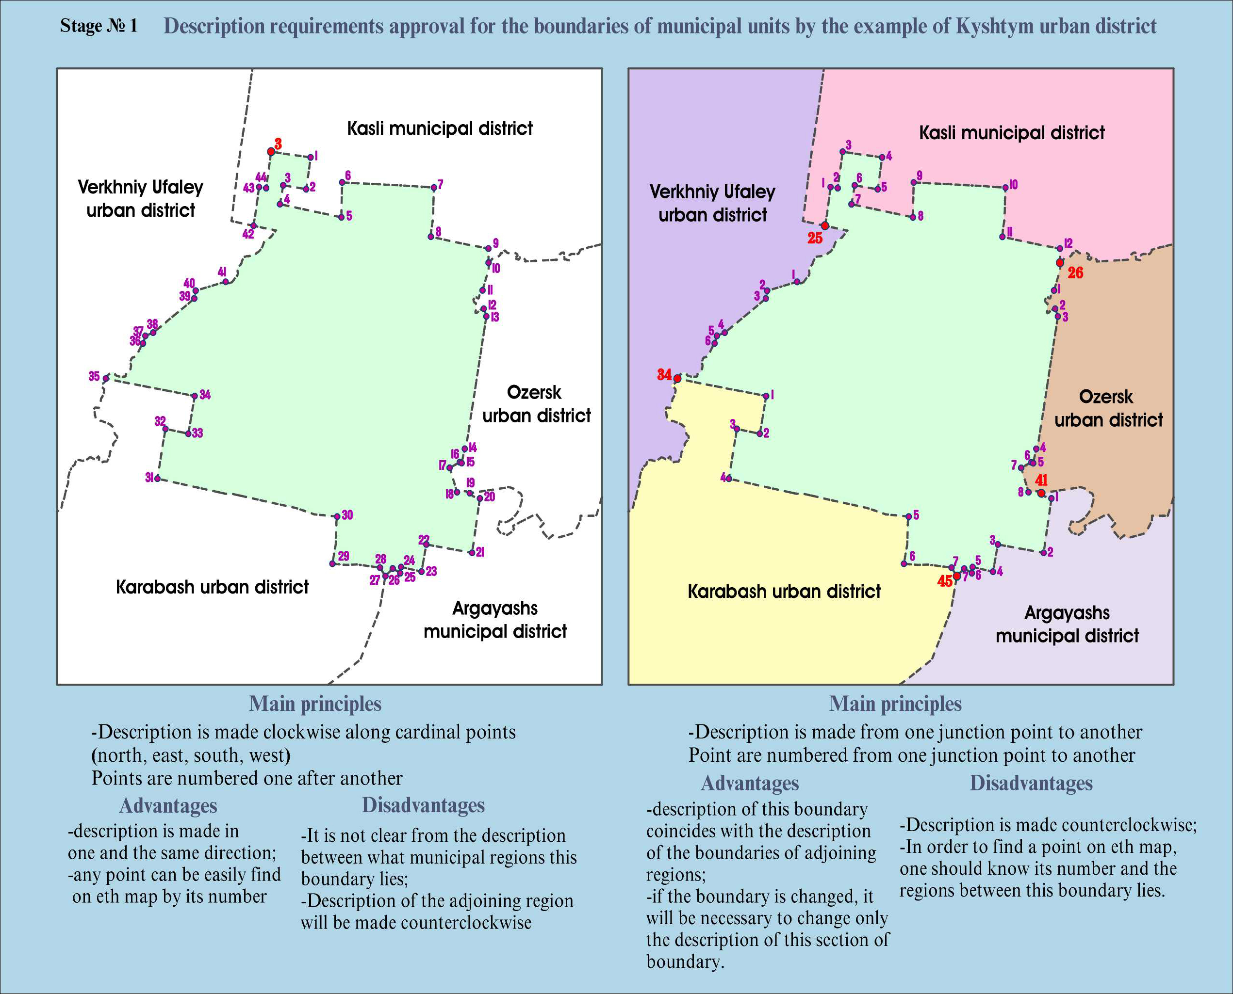

It was decided to make a description of boundaries applying the second procedure, i.e. for each boundary section from one junction point to another.
Boundary sections were printed on the maps at a scale of 1:25 000 (paper size A series 297 x 420 mm/11.7 x 16.5 in), and the description of a boundary was made.
First, with the view of approving boundaries, specially appointed officials representing municipal units and Chairmen of Land Committees of 5-6 adjoining territories were invited. They checked mapped boundaries for errors and made corrections.
After that the amended material in 4 copies was submitted for final approval to the regions. This material first was subject to bilateral signing by the heads of municipal units, heads of Boards (Assemblies) of deputies and heads of Land Committees, after that it was signed by head of regional Land Committee.
Sometimes the approval procedure was very hot. It was very difficult to agree upon boundaries for some disputable places involving conflicts of land and property interests. For example, two municipal units laid claim on one and the same territory (with already existing profitable production facilities, promising recreation area). On the other hand, some problem territories remained unclaimed – municipal units were willing to get rid of them.
Thus, the boundary between Emanzhelinskiy and Yvelskiy municipal units was amended for times on the level heads of municipal units. It became possible to agree upon the boundary only after the interference of the Legislative assembly of the Chelyabinsk region.
After the boundaries were finally agreed upon, cartographic description for each municipal unit was made. First, the description of contiguous zones were made, specifying boundary length in kilometers. After that the boundary was described in sections from one junction point to another. Boundaries coinciding with the state boundary or the boundary of the region, were not described, as they are under the management of the Russian Federation. In this case boundary location is described according to the data of advance sheet.
This description was completed with boundary sketch at a scale of 1:50 000 – 1:200 000 (paper size A series 120 x 297 mm/8.3 x 11.7 in).
This material was submitted to the Legislative Assembly of the Chelyabinsk region.
The performed works revealed discrepancy in relation to cadastral division of the Chelyabinsk region. The appropriate agencies shall make corrections of cadastral units at the places of identified discrepancies.
With the view of efficient development of the territories and successful activities of executive bodies it is proposed to establish global information space, the boundaries of municipal units of the Chelyabinsk region being the part hereof.

